UNITED STATES
SECURITIES AND EXCHANGE COMMISSION
Washington, D.C. 20549

FORM 6-K

REPORT OF FOREIGN PRIVATE ISSUER
PURSUANT TO RULE 13a-16 OR 15d-16
UNDER THE SECURITIES EXCHANGE ACT OF 1934

For the month of September 2026

Commission File Number: 001-42026

YYForce Inc.

60 Paya Lebar Road
#09-13/14/15/16/17
Paya Lebar Square
Singapore 409051
(Address of principal executive offices)

Indicate by check mark whether the registrant files or will file annual reports under cover of Form 20-F or Form 40-F:

Form 20-F ☒ Form 40-F ☐

Incorporation by Reference

This report on Form 6-K and the attached exhibits are incorporated by reference into the Company’s registration statements on Form F-3, as amended (File Nos. 333-297406 and 333-286705), Form S-8 (File Nos. 333-283532, 333-284540, and 333-283532) and into each prospectus outstanding under the foregoing registration statements, to the extent not superseded by documents or reports subsequently filed or furnished by the Company under the Securities Exchange Act of 1934, as amended.

1

EXHIBIT INDEX

Exhibit No. |  | Description
99.1 |  | Press Release dated September 22, 2026
99.2 |  | September 2026 Investor Deck

2

SIGNATURES

Pursuant to the requirements of the Securities Exchange Act of 1934, the registrant has duly caused this report to be signed on its behalf by the undersigned, thereunto duly authorized.

 | YYForce Inc.
Date: September 22, 2026 | By: | /s/ Fu Xiaowei
 | Name: | Fu Xiaowei
 | Title: | Chief Executive Officer, Chairman and Director

3

Exhibit 99.1



YYForce Unveils 2030 Vision to Build an Integrated Human, AI and Robotics Workforce Ecosystem

“Forging Forward Together” — Strategy combines on-demand staffing, AI-powered workforce technology, humanoid robots, Robotics-as-a-Service and smart facility management across hospitality, healthcare, logistics, retail and property operations

SINGAPORE, Sept. 22, 2026 /PRNewswire/ -- YYForce Inc. (NASDAQ: YFOR) (“YYForce” or the “Company”), an AI-enabled workforce management platform and integrated facility management (IFM) provider operating across Asia and beyond, today announced its YYForce 2030 Vision, a long-term strategy to build an integrated workforce ecosystem connecting human workers, artificial intelligence (“AI”), humanoid robots and specialized service robotics.

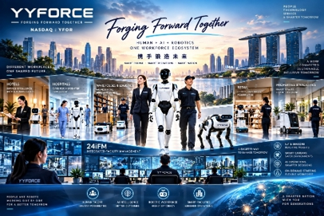
YYForce’s integrated Human, AI and Robotics workforce ecosystem.

Guided by its motto, “Forging Forward Together,” YYForce envisions a future in which people and intelligent machines work alongside one another — combining human judgment, adaptability and service capabilities with the efficiency, scalability and automation potential of AI and robotics.

Under the strategy, YYForce intends to evolve from primarily providing workforce and facility services toward becoming a Future Workforce Solutions Provider, using technology to coordinate human and robotic resources across labor-intensive industries.

The Company’s vision brings together three core capabilities: on-demand human staffing through YY Circle and Yolara AI; humanoid and specialized service robotics offered through leasing and Robotics-as-a-Service (“RaaS”) models; and smart facility management through 24iFM, IoT devices, sensors, smart cameras and automation technologies.

YYForce believes these capabilities could ultimately enable hotels, healthcare facilities, warehouses, logistics operators, retailers, property owners and other service operators to access and manage human workers and robotic resources through an increasingly integrated technology ecosystem.

Human + AI + Robotics: The YYForce Future Workforce

YYForce believes the next generation of workforce solutions will move beyond traditional manpower deployment.

Instead, businesses will increasingly determine whether each operational task should be performed by a human worker, assisted by AI, supported by robotics, or completed through an automated system.

YYForce’s 2030 strategy is designed around coordinating these resources within a unified operating ecosystem.

The Company refers to this model as Future Workforce Solutions.

Rather than seeking to replace people, YYForce intends to use AI and robotics to augment human capabilities, particularly in environments involving repetitive, physically demanding, standardized or continuously monitored tasks.

Human workers can therefore remain focused on activities requiring judgment, communication, problem-solving, adaptability and customer interaction.

This philosophy is reflected in YYForce’s motto:

Forging Forward Together — Humans. AI. Robotics.

Layer One: On-Demand Human Workforce

YYForce’s existing workforce technology provides the human workforce foundation for its 2030 strategy.

Through YY Circle and Yolara AI, the Company is developing technology designed to connect businesses with flexible and on-demand workforce resources while improving workforce matching, deployment and management.

This capability is intended to support industries characterized by fluctuating workforce requirements, distributed operations and significant frontline labor needs, including hospitality and hotels, healthcare and hospitals, warehousing and logistics, retail, commercial and residential properties, facility management and other service-intensive industries.

The long-term objective is to enable businesses to access workforce capacity more dynamically according to operational demand.

Layer Two: Humanoid Robots and Robotics-as-a-Service

YYForce intends to progressively explore the integration of humanoid robots and specialized service robotics into its workforce ecosystem.

Potential robotic applications could include cleaning, internal delivery, material movement, inspection, monitoring, logistics support and other repetitive or standardized operational activities.

Rather than requiring customers to purchase robotic equipment outright, YYForce’s strategy includes evaluating leasing and Robotics-as-a-Service models.

Under this approach, service operators could potentially deploy robotics according to operational requirements while YYForce and its ecosystem partners provide deployment, integration and related services.

This model could create recurring revenue opportunities for YYForce while lowering the initial capital requirements for customers seeking to adopt automation.

2

Layer Three: 24iFM — Connecting People, Robotics and Physical Facilities

YYForce’s integrated facility management strategy represents the third component of the ecosystem.

Through 24iFM, combined with IoT devices, sensors, smart cameras, robotics and automation technologies, YYForce aims to create an increasingly connected environment where property owners and facility operators can manage physical assets, service requests and operational resources through centralized systems.

The Company envisions a future where a facility operations team can oversee multiple ground activities from a centralized control room.

Data generated by connected buildings could help operations teams identify requirements in real time. Depending on the task, the system could then facilitate the deployment of an available human worker, specialized robot, humanoid robot or automated workflow.

For example, sensors could identify a facility requirement; 24iFM could surface the event to the operations team; the appropriate human or robotic resource could be assigned; and task completion could subsequently be monitored through the same operating environment.

This represents YYForce’s longer-term transition from conventional facility management toward technology-enabled, data-driven facility orchestration.

One Ecosystem Across Multiple Industries

The YYForce 2030 Vision is designed to be applicable across multiple service-intensive industries.

In a hotel, human hospitality personnel could work alongside cleaning, delivery and service robots.

In a hospital or healthcare facility, human personnel could be supported by robots performing appropriate logistics, transportation or facility-related tasks.

In a warehouse, flexible human workers could operate alongside autonomous and robotic material-handling systems.

In retail, frontline employees could be supported by robotics and automated operational systems.

Across commercial and residential properties, facility operators could use 24iFM to coordinate people, equipment, service requests, IoT devices and robotic resources from a centralized operating environment.

From Workforce Provider to Workforce Orchestrator

The YYForce 2030 Vision represents a longer-term evolution of the Company’s business model:

Human Workforce
YY Circle + Yolara AI

Artificial Intelligence
Workforce matching + operational intelligence + automation

Robotic Workforce
Humanoid robots + specialized service robotics + Robotics-as-a-Service

Smart Facilities
24iFM + IoT + sensors + smart cameras + automation

Together, these components are intended to create a connected ecosystem capable of coordinating people, machines and physical environments.

“The workforce of 2030 will not simply be human or robotic. We believe it will be human, AI and robotics working together,” said Mike Fu, Chief Executive Officer of YYForce. “Our vision is for YYForce to become the technology and operating layer that connects these resources and enables businesses to deploy the right resource for the right task at the right time.”

“Forging Forward Together represents what we believe the future of work should look like — people and technology advancing together. Our goal is not simply to introduce more automation, but to create an ecosystem where human talent, AI and robotics complement one another to deliver better operational outcomes.”

3

Building Toward 2030

YYForce expects to pursue its 2030 strategy progressively through a combination of technology development, commercial partnerships, robotics collaborations, pilot programs and potential strategic investments.

The Company intends to evaluate opportunities based on customer requirements, technological maturity, economics and commercial scalability.

YYForce believes its existing presence across workforce solutions and integrated facility management provides a foundation from which the Company can progressively connect human workforce deployment, AI, robotics and smart facility infrastructure.

The long-term objective is to build an ecosystem where customers do not simply procure manpower, software or robots independently.

Instead, they can access a Future Workforce Solution designed around the operational outcome they need.

Investor Presentation

Additional information regarding the YYForce 2030 Vision, including the Company’s strategic roadmap and operating framework, is available in the YYForce 2030 Investor Strategy Presentation on the Company’s Investor Relations website at Investor Strategy Deck.

YYForce 2030

Human + AI + Robotics. One Workforce Ecosystem.

Forging Forward Together.

About YYForce Inc.

YYForce Inc. (Nasdaq: YFOR) is an AI-enabled workforce management platform and IFM provider, headquartered in Singapore and operating across Asia and beyond. The Company's intelligent workforce solutions platform, YY Circle, helps clients across hospitality, food and beverage, retail, and other service sectors predict, plan, and optimize workforce deployment. In YYForce's IFM business, its 24IFM software platform and comprehensive IFM subsidiary portfolio support clients across hospitality, transportation, banking, retail, and mixed-use facilities.

As both business lines scale, the Company is systematically embedding AI and automation capabilities – progressing from intelligent decision support toward increasingly autonomous workforce management – to improve service quality, reduce deployment costs, and drive long-term margin expansion. Listed on the Nasdaq Capital Market, YYForce is committed to infrastructure innovation, measurable client outcomes, and long-term value creation.

Forward-Looking Statements

This press release contains forward-looking statements within the meaning of Section 27A of the Securities Act of 1933, as amended, and Section 21E of the Securities Exchange Act of 1934, as amended. The Company bases these forward-looking statements on its expectations and projections about future events, which the Company derives from the information currently available to it. You can identify forward-looking statements by those that are not historical in nature, particularly those that use terminology such as “may,” “should,” “expects,” “anticipates,” “contemplates,” “estimates,” “believes,” “plans,” “projected,” “predicts,” “potential,” or “hopes” or the negative of these or similar terms. Forward-looking statements involve inherent risks and uncertainties, and the forward-looking events discussed in this press release may not occur, and actual events and results may differ materially and are subject to risks, uncertainties, and assumptions about the Company and a number of factors. These factors include, but are not limited to, the Company’s goals and strategies; the Company’s future business development, financial condition and results of operations, including the introduction of new products and services, expected changes in the Company’s revenues, costs and expenditures, anticipated customer growth, and demand for and market acceptance of the Company’s products and services; and industry, market and regulatory conditions, including competition, government policies and regulations affecting the Company’s industry, and other factors that may affect the Company’s financial condition, liquidity and results of operations. For a more detailed discussion of risk factors, please refer to the Company’s filings with the Securities and Exchange Commission, including the “Risk Factors” section of the Company’s most recent annual report on Form 20-F, as amended.

Investor Contact
Jason Zhi Yong Phua, Chief Financial Officer
YYForce Inc.
enquiries@yyforce.ai

Investor Relations Contact
Piacente Financial Communications
yfor@thepiacentegroup.com

4

Exhibit 99.2

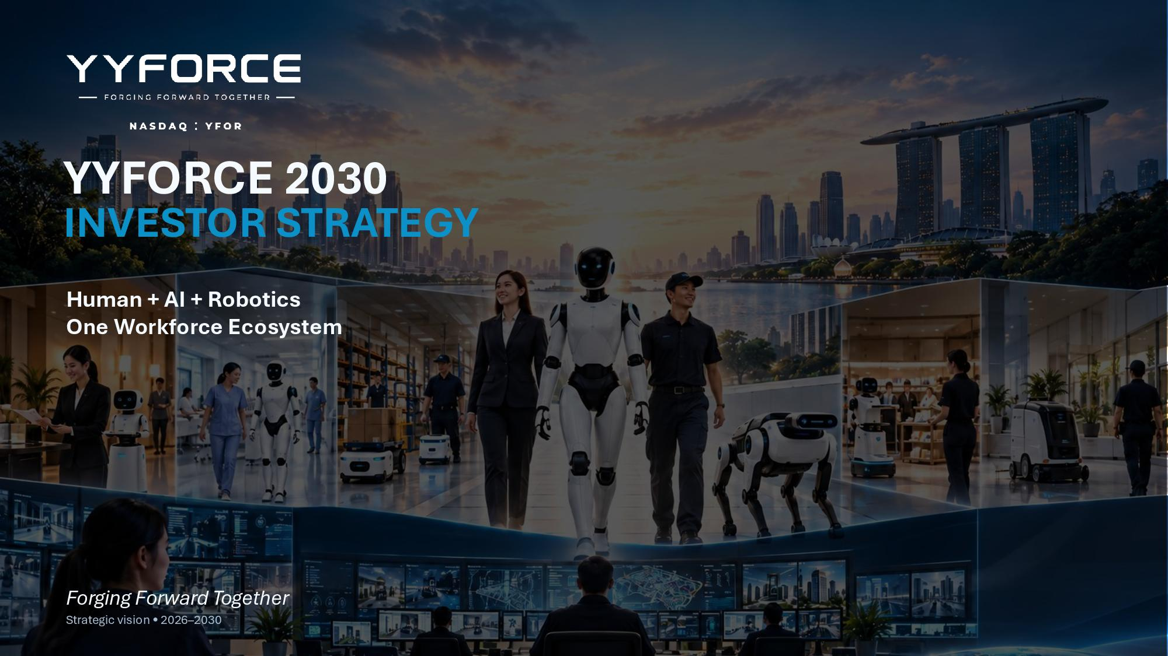
YYFORCE 2030 INVESTOR STRATEGY Human + AI + Robotics One Workforce Ecosystem Forging Forward Together Strategic vision • 2026 – 2030

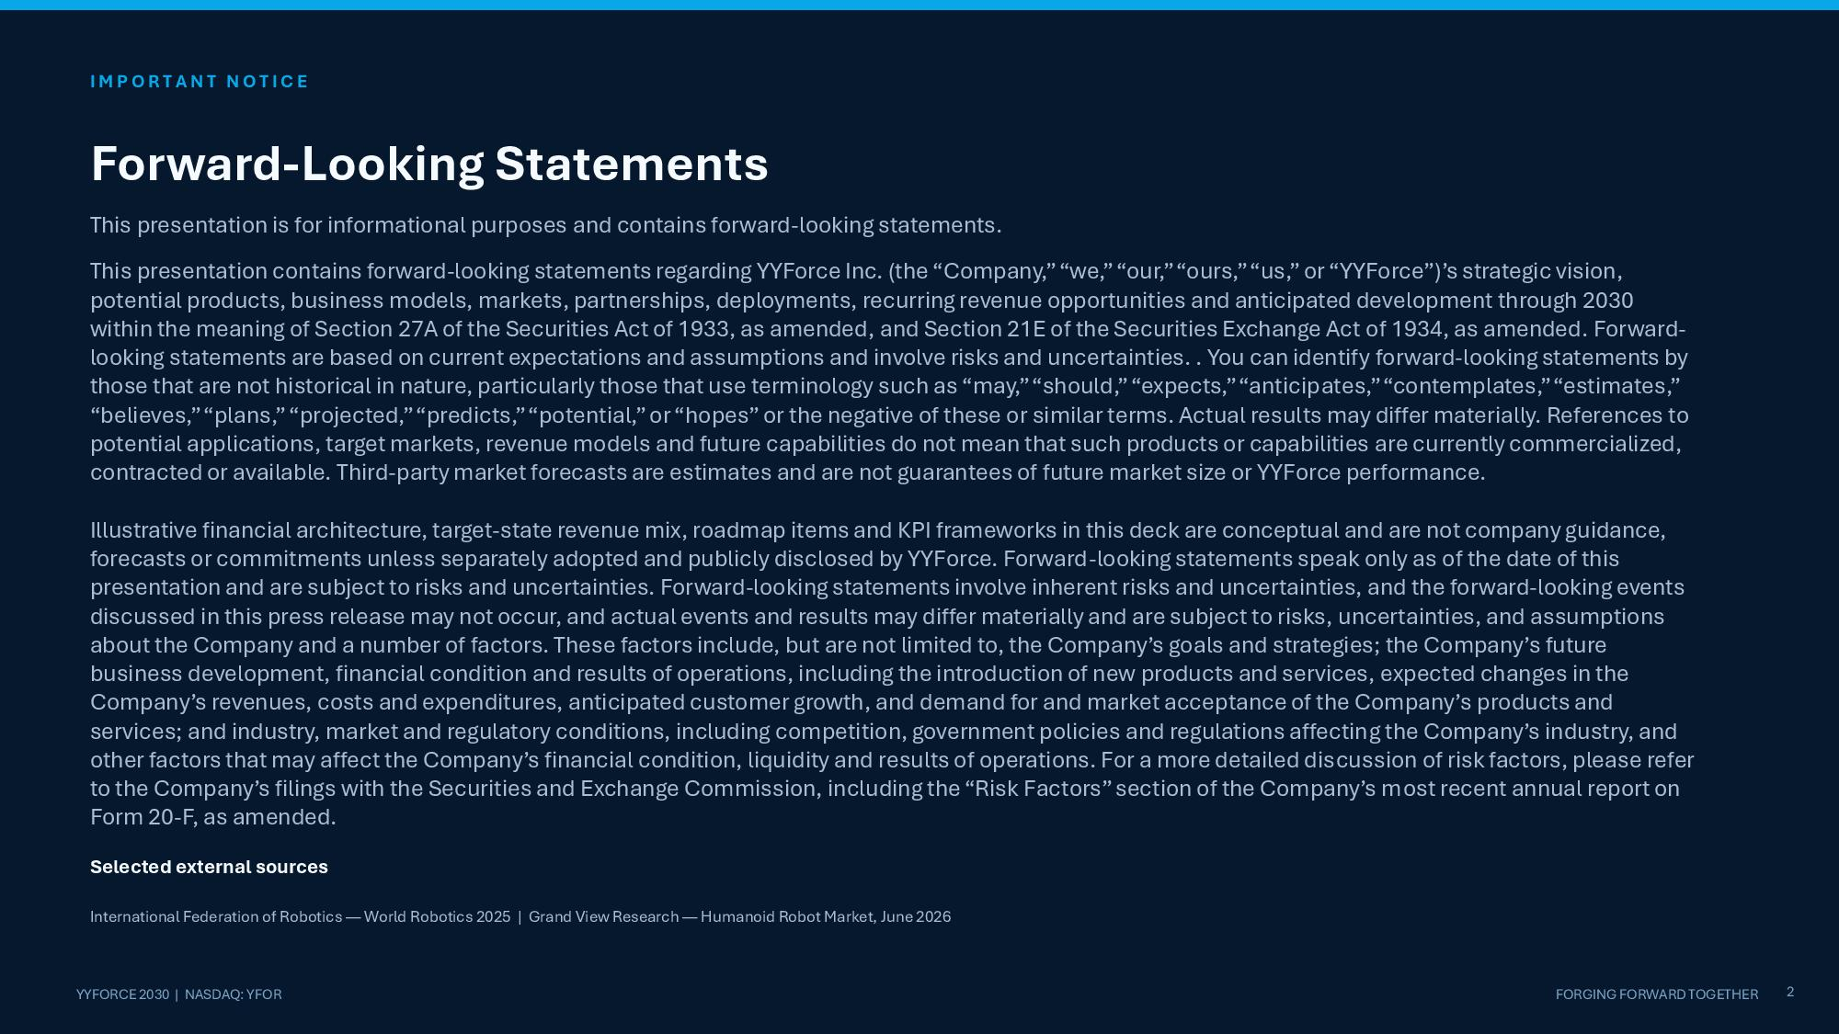
I M P O R T A N T N O T I C E 2 YYFORCE 2030 | NASDAQ: YFOR FORGING FORWARD TOGETHER Forward - Looking Statements This presentation is for informational purposes and contains forward - looking statements. This presentation contains forward - looking statements regarding YYForce Inc. (the “Company,” “we,” “our,” “ours,” “us,” or “YYForce”)’s strategic vision, potential products, business models, markets, partnerships, deployments, recurring revenue opportunities and anticipated development through 2030 within the meaning of Section 27A of the Securities Act of 1933, as amended, and Section 21E of the Securities Exchange Act of 1934, as amended. Forward - looking statements are based on current expectations and assumptions and involve risks and uncertainties. . You can identify forward - looking statements by those that are not historical in nature, particularly those that use terminology such as “may,” “should,” “expects,” “anticipates,” “contemplates,” “estimates,” “believes,” “plans,” “projected,” “predicts,” “potential,” or “hopes” or the negative of these or similar terms. Actual results may differ materially. References to potential applications, target markets, revenue models and future capabilities do not mean that such products or capabilities are currently commercialized, contracted or available. Third - party market forecasts are estimates and are not guarantees of future market size or YYForce performance. Illustrative financial architecture, target - state revenue mix, roadmap items and KPI frameworks in this deck are conceptual and are not company guidance, forecasts or commitments unless separately adopted and publicly disclosed by YYForce. Forward - looking statements speak only as of the date of this presentation and are subject to risks and uncertainties. Forward - looking statements involve inherent risks and uncertainties, and the forward - looking events discussed in this press release may not occur, and actual events and results may differ materially and are subject to risks, uncertainties, and assumptions about the Company and a number of factors. These factors include, but are not limited to, the Company’s goals and strategies; the Company’s future business development, financial condition and results of operations, including the introduction of new products and services, expected changes in the Company’s revenues, costs and expenditures, anticipated customer growth, and demand for and market acceptance of the Company’s products and services; and industry, market and regulatory conditions, including competition, government policies and regulations affecting the Company’s industry, and other factors that may affect the Company’s financial condition, liquidity and results of operations. For a more detailed discussion of risk factors, please refer to the Company’s filings with the Securities and Exchange Commission, including the “Risk Factors” section of the Company’s most recent annual report on Form 20 - F, as amended. Selected external sources International Federation of Robotics — World Robotics 2025 | Grand View Research — Humanoid Robot Market, June 2026

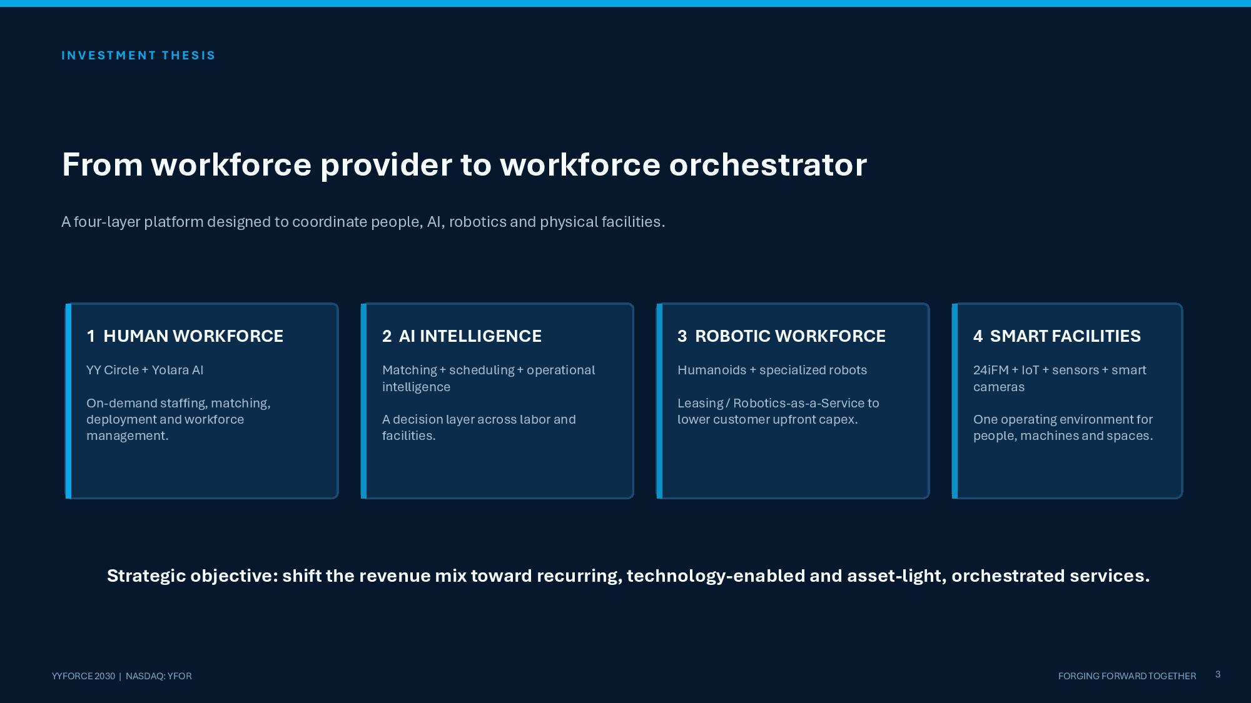
I N V E S T M E N T T H E S I S From workforce provider to workforce orchestrator A four - layer platform designed to coordinate people, AI, robotics and physical facilities. 1 HUMAN WORKFORCE YY Circle + Yolara AI On - demand staffing, matching, deployment and workforce management. 2 AI INTELLIGENCE Matching + scheduling + operational intelligence A decision layer across labor and facilities. 3 ROBOTIC WORKFORCE Humanoids + specialized robots Leasing / Robotics - as - a - Service to lower customer upfront capex. 4 SMART FACILITIES 24iFM + IoT + sensors + smart cameras 3 YYFORCE 2030 | NASDAQ: YFOR FORGING FORWARD TOGETHER One operating environment for people, machines and spaces. Strategic objective: shift the revenue mix toward recurring, technology - enabled and asset - light, orchestrated services.

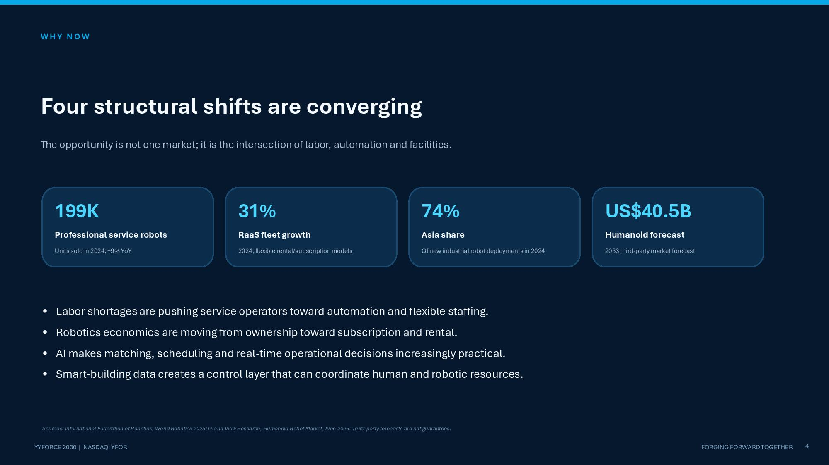
W H Y N O W Four structural shifts are converging The opportunity is not one market; it is the intersection of labor, automation and facilities. 199K Professional service robots Units sold in 2024; +9% YoY 31% RaaS fleet growth 2024; flexible rental/subscription models 74% Asia share Of new industrial robot deployments in 2024 US$40.5B Humanoid forecast 2033 third - party market forecast 4 YYFORCE 2030 | NASDAQ: YFOR FORGING FORWARD TOGETHER • Labor shortages are pushing service operators toward automation and flexible staffing. • Robotics economics are moving from ownership toward subscription and rental. • AI makes matching, scheduling and real - time operational decisions increasingly practical. • Smart - building data creates a control layer that can coordinate human and robotic resources. Sources: International Federation of Robotics, World Robotics 2025; Grand View Research, Humanoid Robot Market, June 2026. Third - party forecasts are not guarantees.

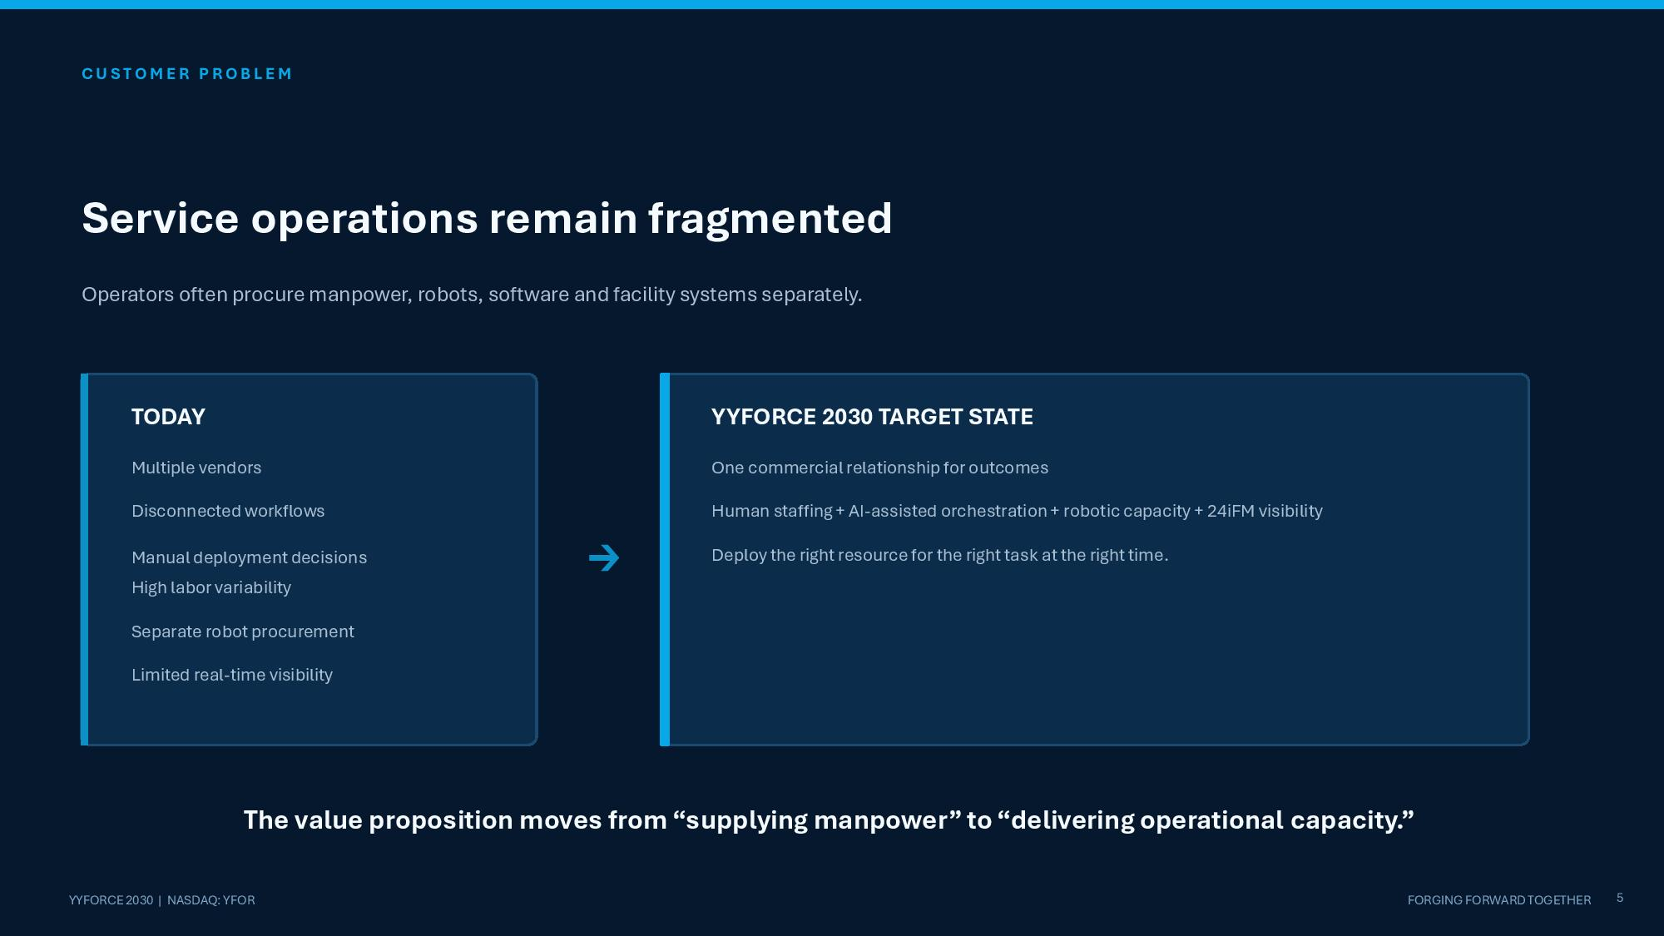
C U S T O M E R P R O B L E M Service operations remain fragmented Operators often procure manpower, robots, software and facility systems separately. TODAY Multiple vendors Disconnected workflows Manual deployment decisions High labor variability Separate robot procurement Limited real - time visibility → YYFORCE 2030 TARGET STATE One commercial relationship for outcomes Human staffing + AI - assisted orchestration + robotic capacity + 24iFM visibility Deploy the right resource for the right task at the right time. 5 YYFORCE 2030 | NASDAQ: YFOR FORGING FORWARD TOGETHER The value proposition moves from “supplying manpower” to “delivering operational capacity.”

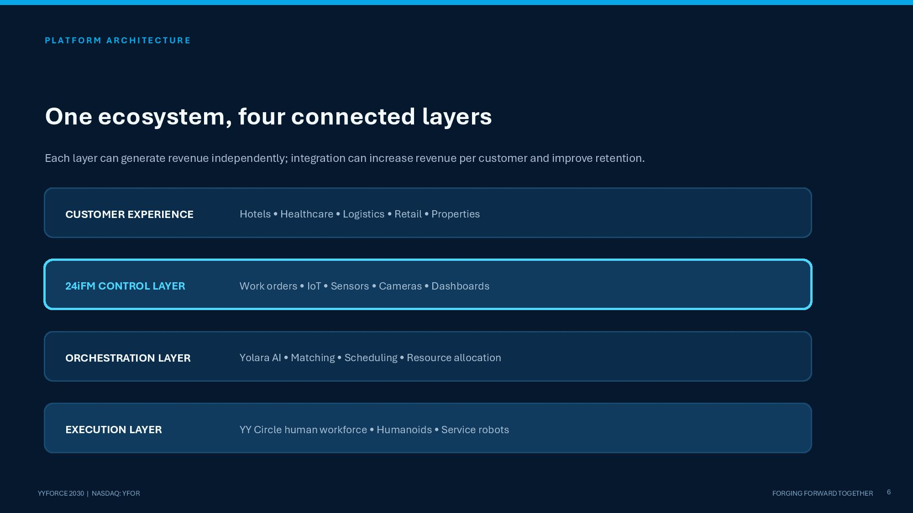
P L A T F O R M A R C H I T E C T U R E One ecosystem, four connected layers Each layer can generate revenue independently; integration can increase revenue per customer and improve retention. CUSTOMER EXPERIENCE Hotels • Healthcare • Logistics • Retail • Properties 24iFM CONTROL LAYER Work orders • IoT • Sensors • Cameras • Dashboards ORCHESTRATION LAYER Yolara AI • Matching • Scheduling • Resource allocation EXECUTION LAYER 6 YYFORCE 2030 | NASDAQ: YFOR FORGING FORWARD TOGETHER YY Circle human workforce • Humanoids • Service robots

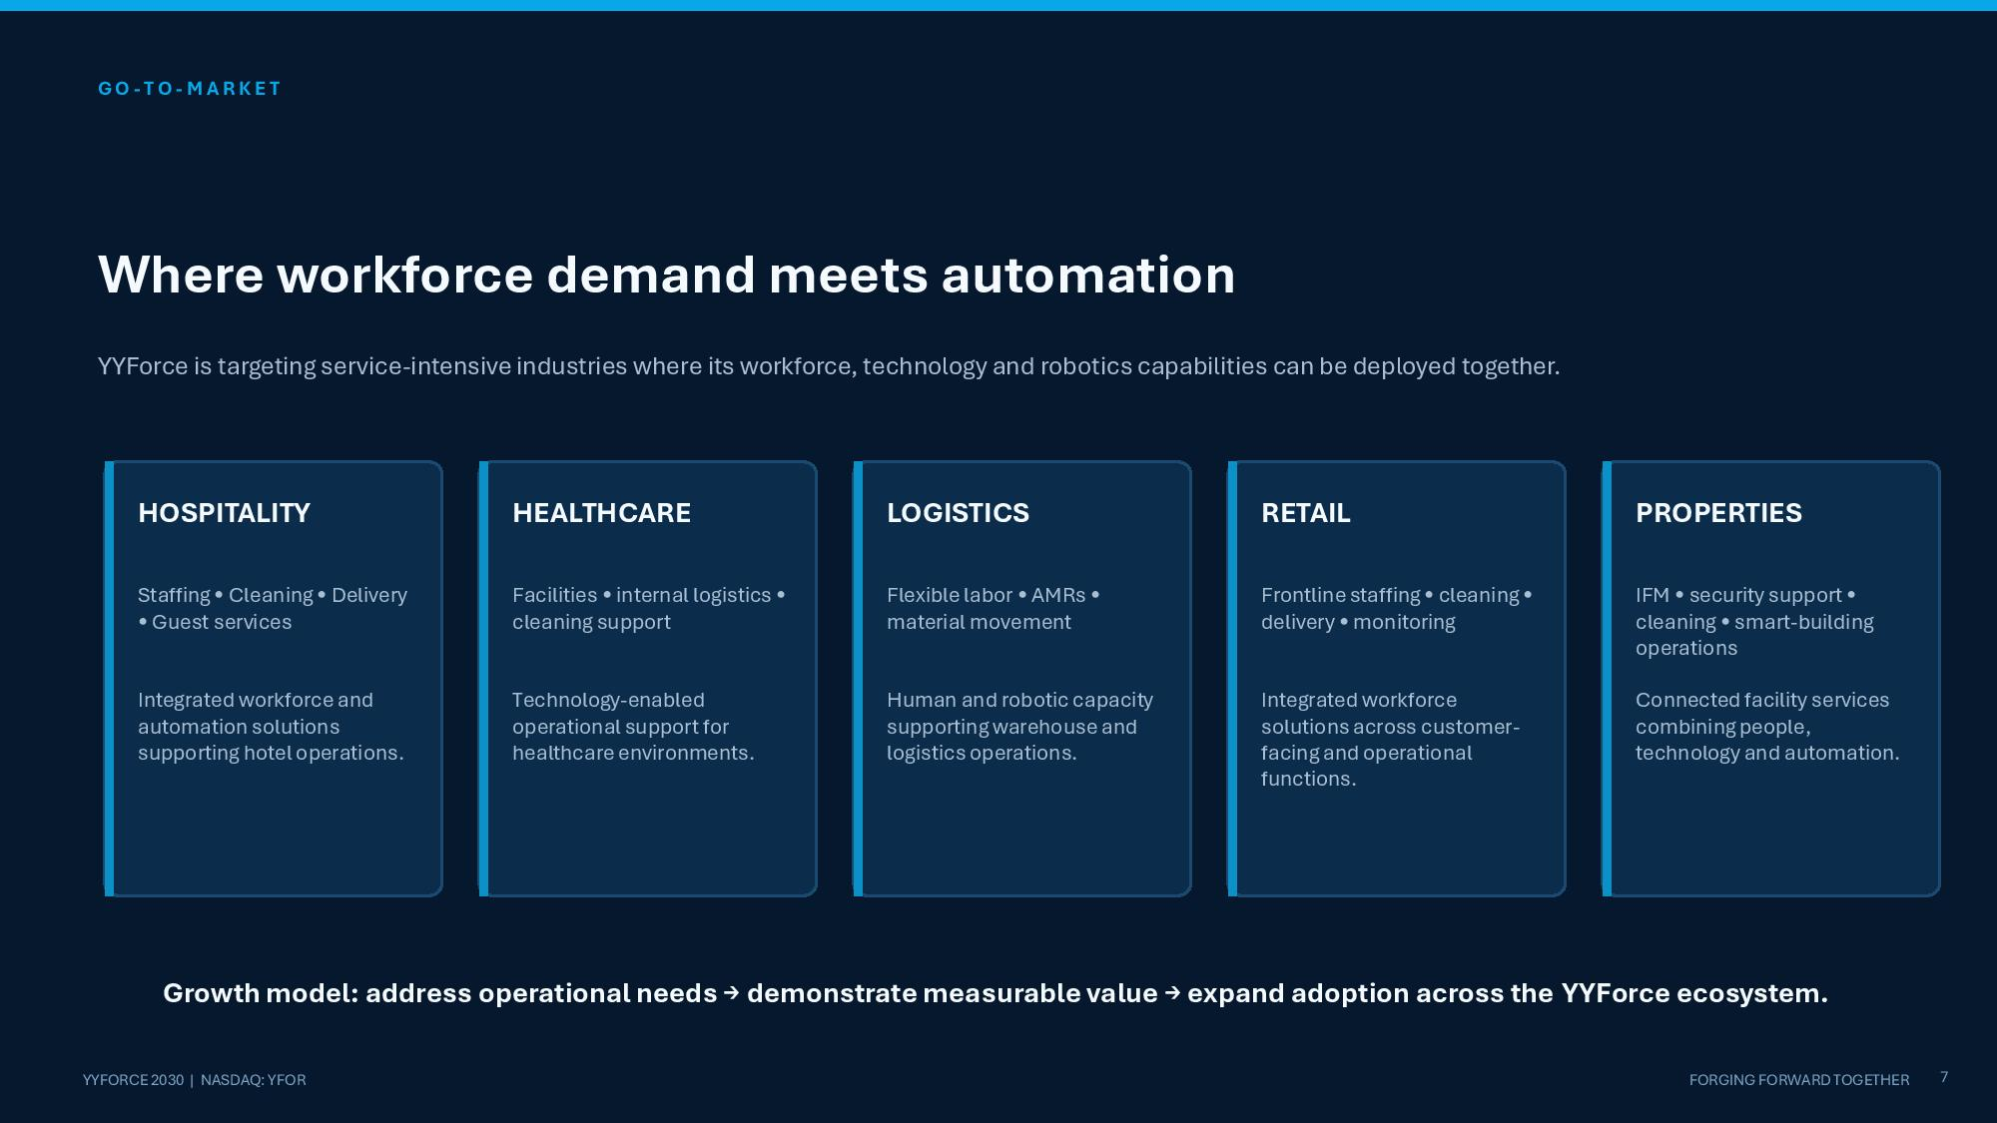
GO - TO - M A R K E T Where workforce demand meets automation YYForce is targeting service - intensive industries where its workforce, technology and robotics capabilities can be deployed together. HOSPITALITY Staffing • Cleaning • Delivery • Guest services Integrated workforce and automation solutions supporting hotel operations. HEALTHCARE Facilities • internal logistics • cleaning support Technology - enabled operational support for healthcare environments. LOGISTICS Flexible labor • AMRs • material movement Human and robotic capacity supporting warehouse and logistics operations. RETAIL Frontline staffing • cleaning • delivery • monitoring Integrated workforce solutions across customer - facing and operational functions. PROPERTIES 7 YYFORCE 2030 | NASDAQ: YFOR FORGING FORWARD TOGETHER IFM • security support • cleaning • smart - building operations Connected facility services combining people, technology and automation. Growth model: address operational needs → demonstrate measurable value → expand adoption across the YYForce ecosystem.

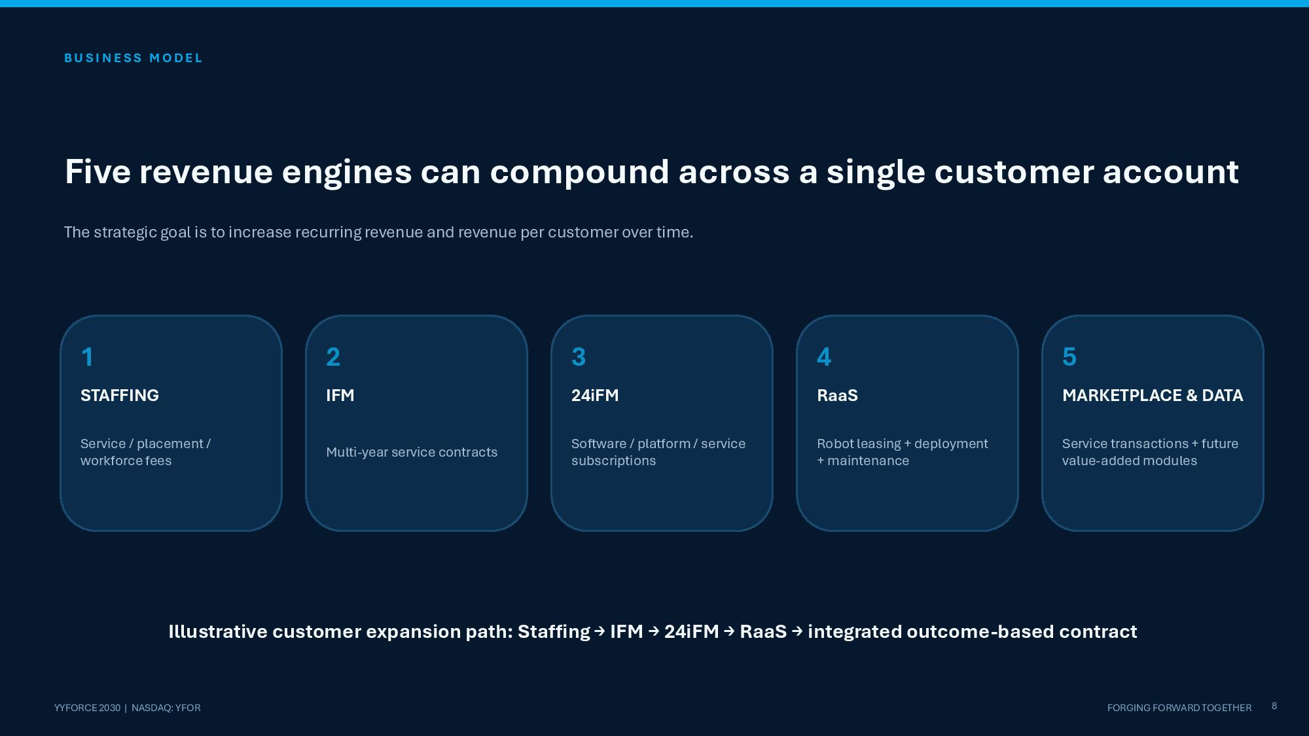
B U S I N E S S M O D E L Five revenue engines can compound across a single customer account The strategic goal is to increase recurring revenue and revenue per customer over time. 1 STAFFING Service / placement / workforce fees 2 IFM Multi - year service contracts 3 24iFM Software / platform / service subscriptions 4 RaaS Robot leasing + deployment + maintenance 5 MARKETPLACE & DATA 8 YYFORCE 2030 | NASDAQ: YFOR FORGING FORWARD TOGETHER Service transactions + future value - added modules Illustrative customer expansion path: Staffing → IFM → 24iFM → RaaS → integrated outcome - based contract

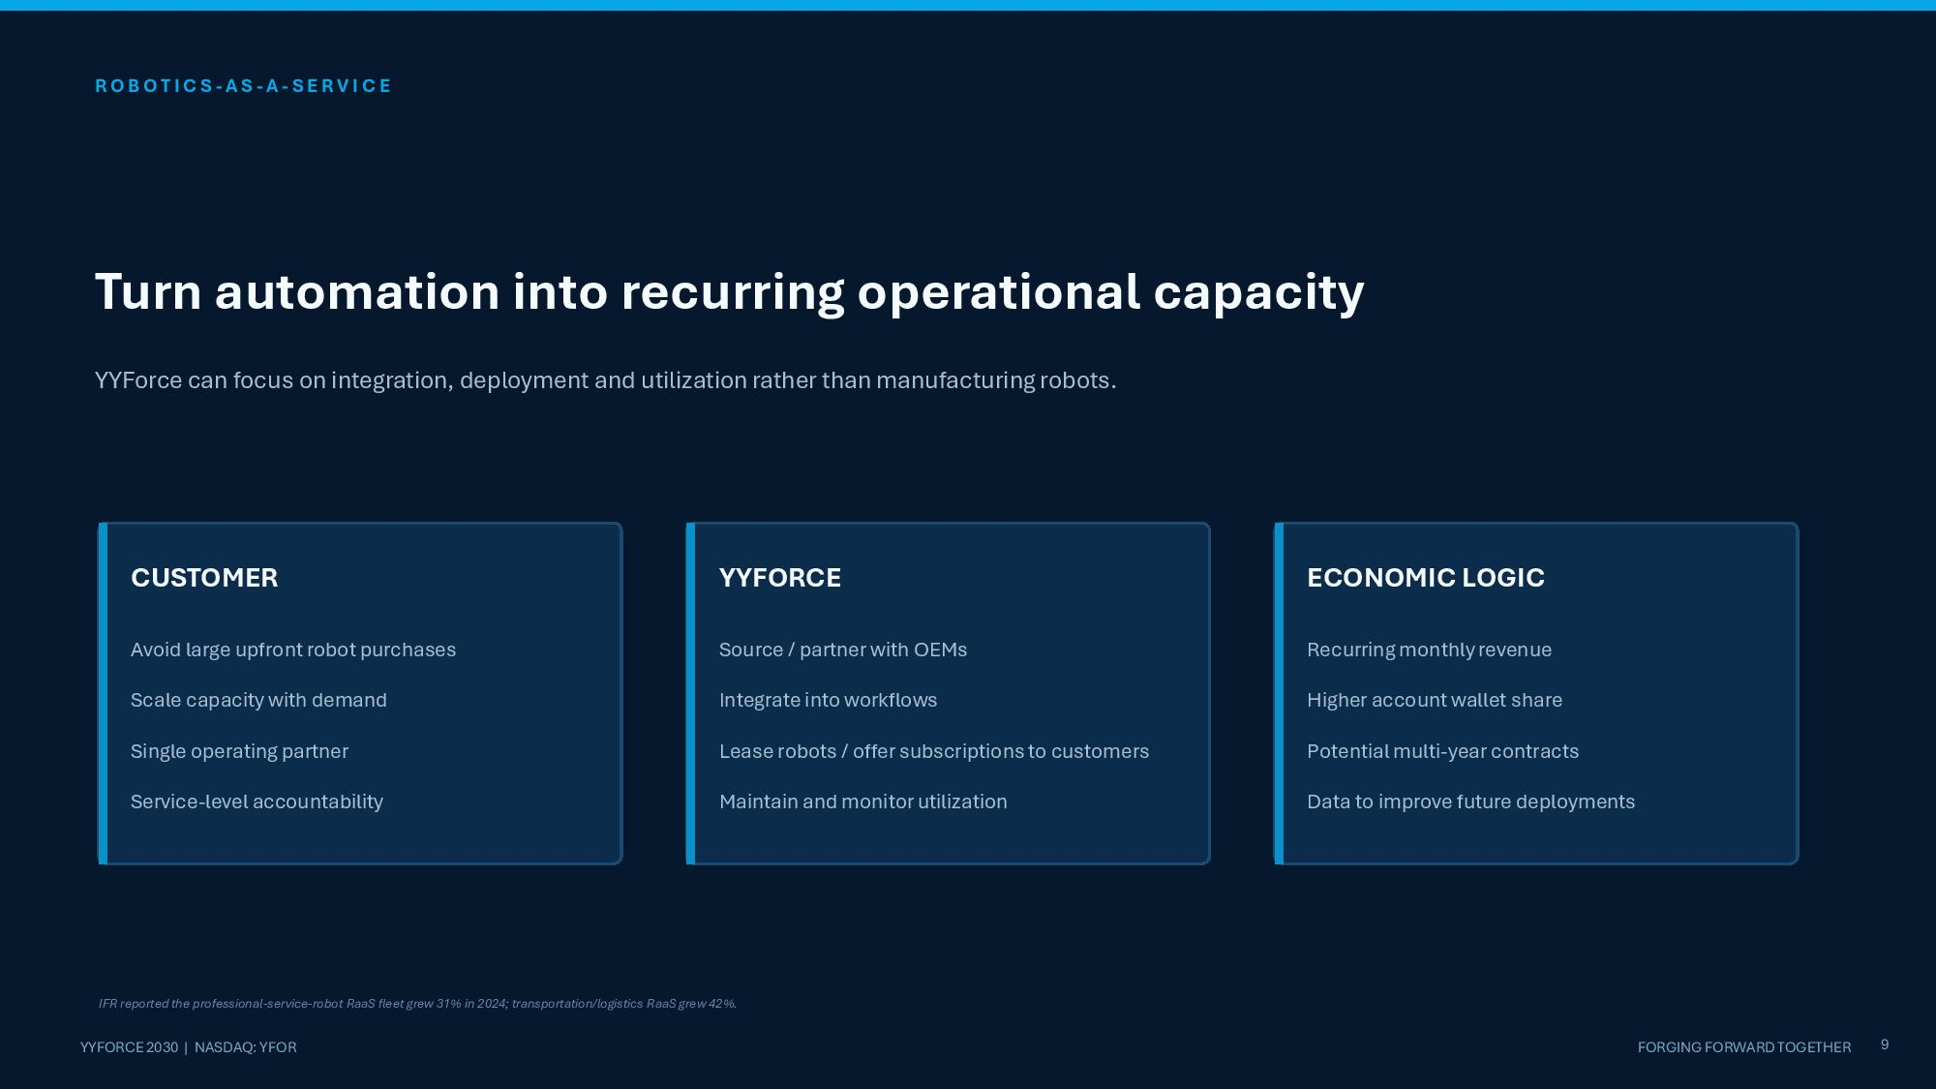
R O B O T I C S - AS - A - S E R V I C E Turn automation into recurring operational capacity YYForce can focus on integration, deployment and utilization rather than manufacturing robots. CUSTOMER Avoid large upfront robot purchases Scale capacity with demand Single operating partner Service - level accountability YYFORCE Source / partner with OEMs Integrate into workflows Lease robots / offer subscriptions to customers Maintain and monitor utilization ECONOMIC LOGIC Recurring monthly revenue Higher account wallet share Potential multi - year contracts Data to improve future deployments 9 YYFORCE 2030 | NASDAQ: YFOR FORGING FORWARD TOGETHER IFR reported the professional - service - robot RaaS fleet grew 31% in 2024; transportation/logistics RaaS grew 42%.

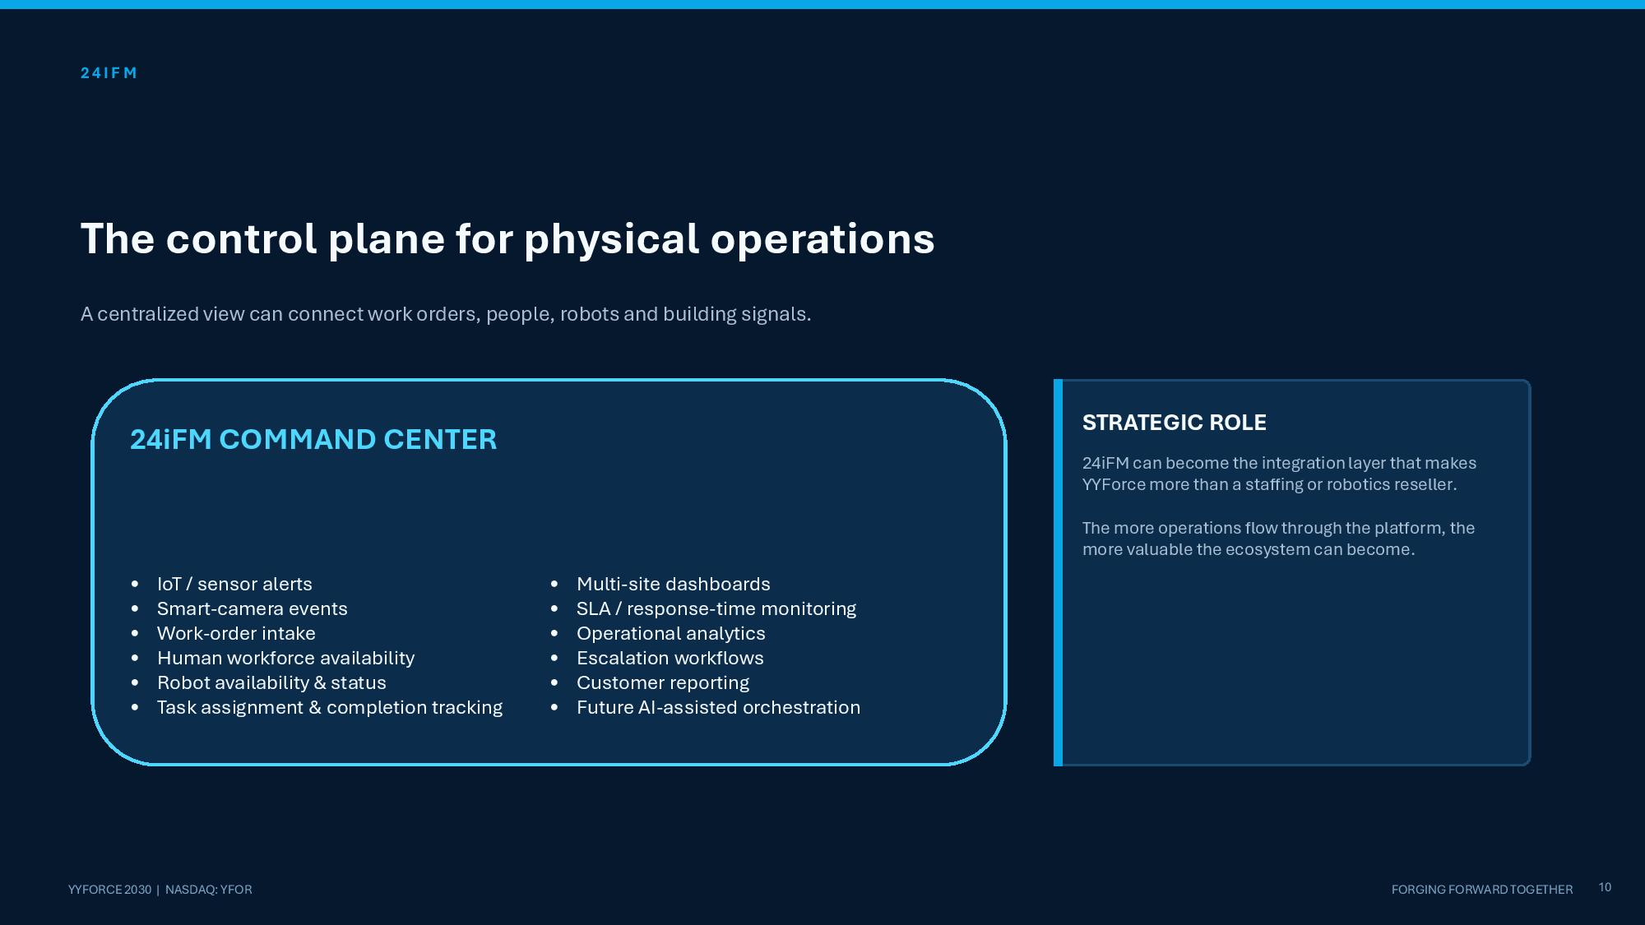
2 4 I F M The control plane for physical operations A centralized view can connect work orders, people, robots and building signals. 24iFM COMMAND CENTER • IoT / sensor alerts • Smart - camera events • Work - order intake • Human workforce availability • Robot availability & status • Task assignment & completion tracking • Multi - site dashboards • SLA / response - time monitoring • Operational analytics • Escalation workflows • Customer reporting • Future AI - assisted orchestration STRATEGIC ROLE 24iFM can become the integration layer that makes YYForce more than a staffing or robotics reseller. The more operations flow through the platform, the more valuable the ecosystem can become. 10 YYFORCE 2030 | NASDAQ: YFOR FORGING FORWARD TOGETHER

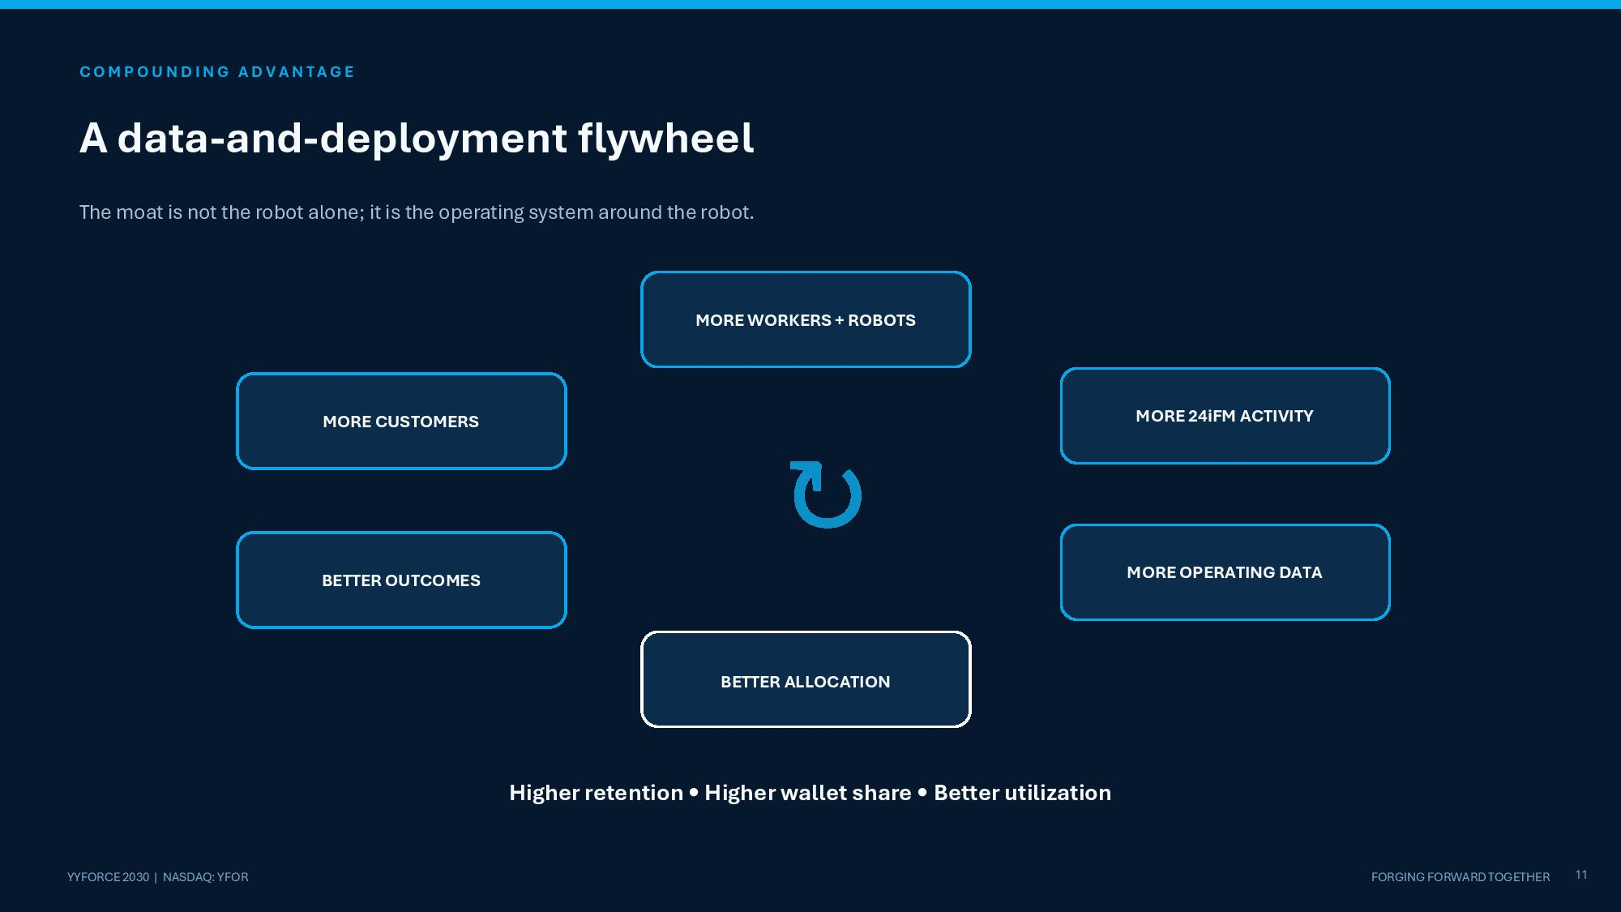
C O M P O U N D I N G A D V A N T A G E A data - and - deployment flywheel The moat is not the robot alone; it is the operating system around the robot. MORE CUSTOMERS MORE WORKERS + ROBOTS MORE 24iFM ACTIVITY MORE OPERATING DATA BETTER ALLOCATION BETTER OUTCOMES 11 YYFORCE 2030 | NASDAQ: YFOR FORGING FORWARD TOGETHER ↻ Higher retention • Higher wallet share • Better utilization

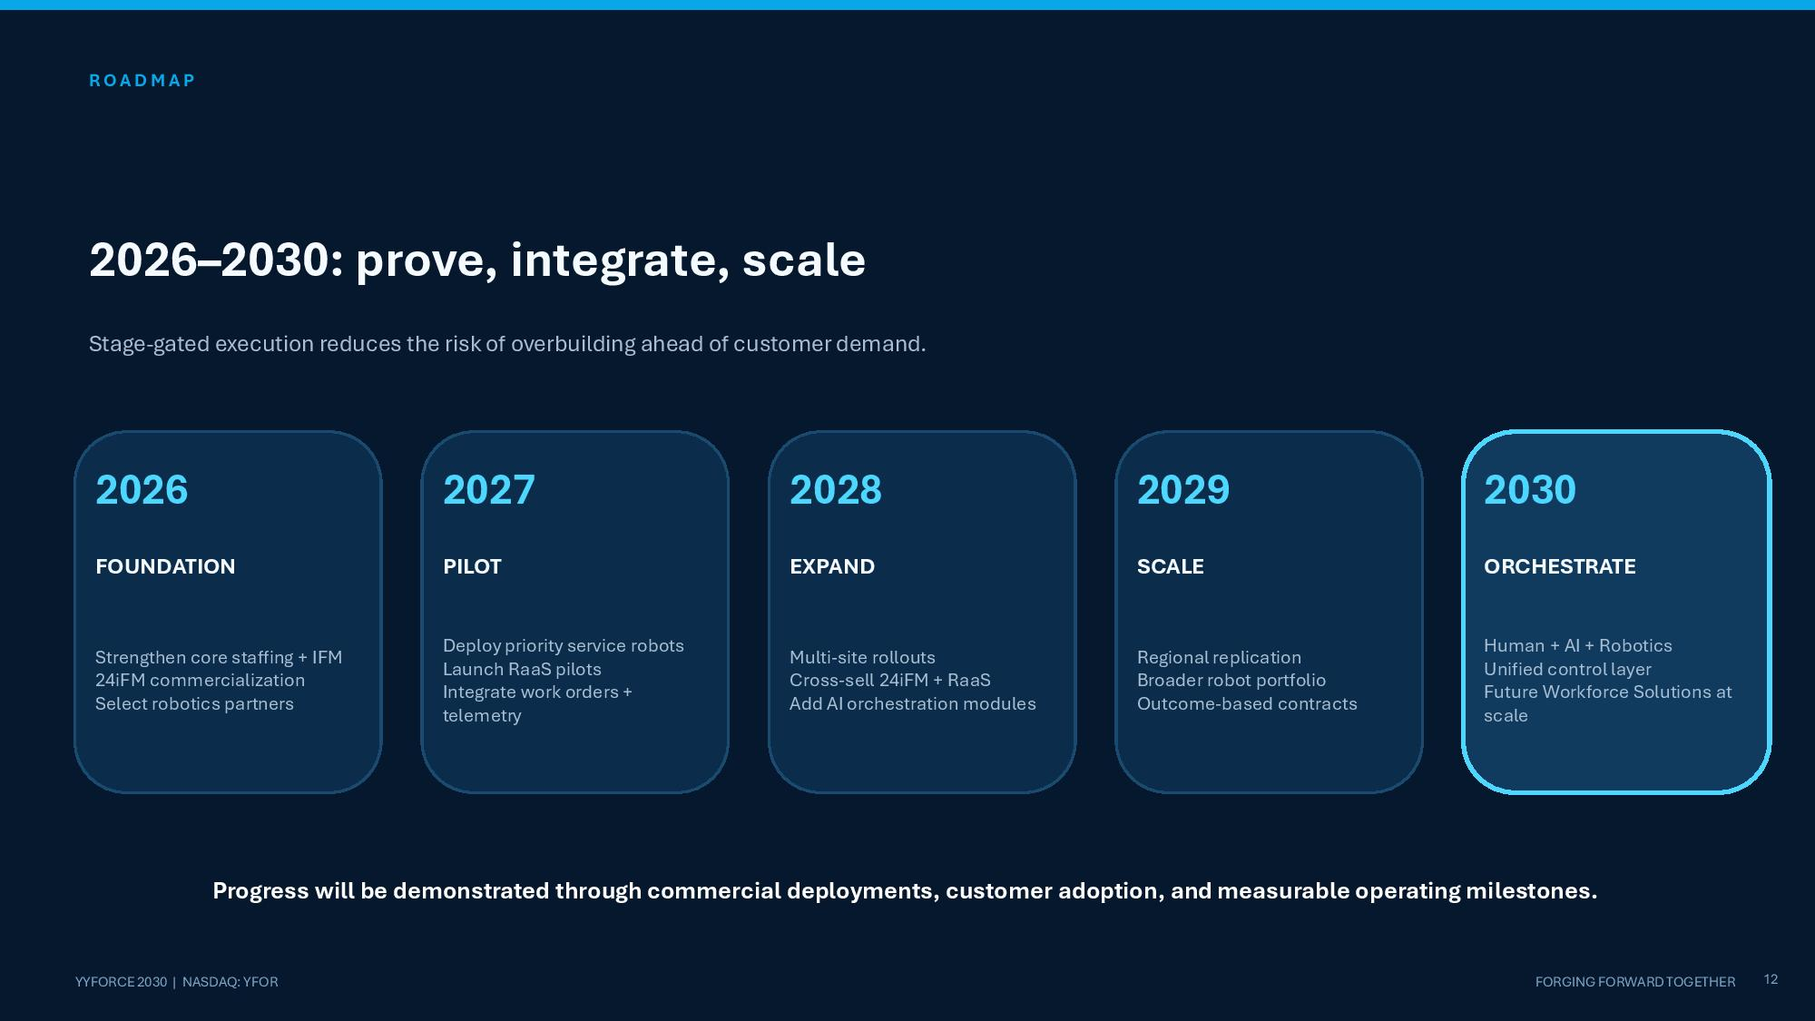
R O A D M A P 2026 – 2030: prove, integrate, scale Stage - gated execution reduces the risk of overbuilding ahead of customer demand. 2026 FOUNDATION Strengthen core staffing + IFM 24iFM commercialization Select robotics partners 2027 PILOT Deploy priority service robots Launch RaaS pilots Integrate work orders + telemetry 2028 EXPAND Multi - site rollouts Cross - sell 24iFM + RaaS Add AI orchestration modules 2029 SCALE Regional replication Broader robot portfolio Outcome - based contracts 2030 ORCHESTRATE 12 YYFORCE 2030 | NASDAQ: YFOR FORGING FORWARD TOGETHER Human + AI + Robotics Unified control layer Future Workforce Solutions at scale Progress will be demonstrated through commercial deployments, customer adoption, and measurable operating milestones.

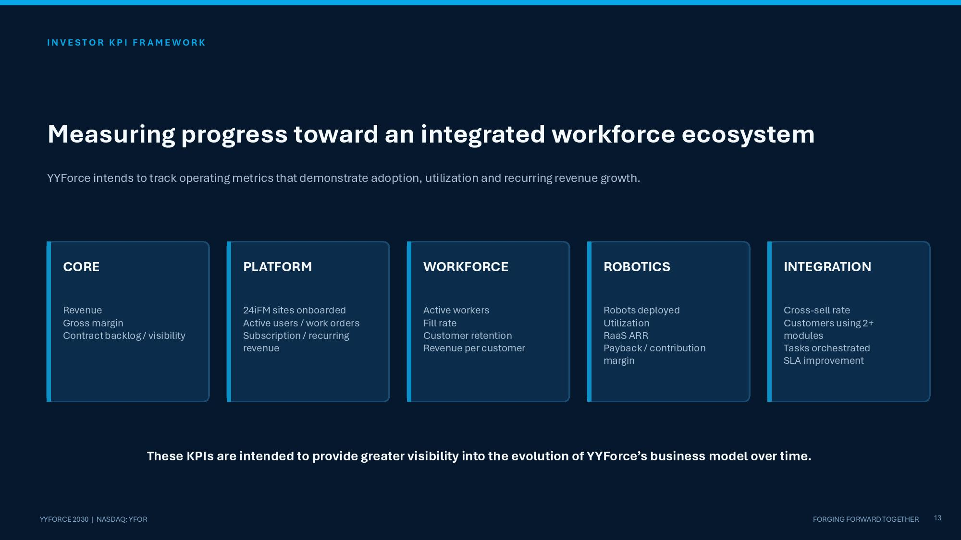
I N V E S T O R K P I F R A M E W O R K Measuring progress toward an integrated workforce ecosystem YYForce intends to track operating metrics that demonstrate adoption, utilization and recurring revenue growth. CORE Revenue Gross margin Contract backlog / visibility PLATFORM 24iFM sites onboarded Active users / work orders Subscription / recurring revenue WORKFORCE Active workers Fill rate Customer retention Revenue per customer ROBOTICS Robots deployed Utilization RaaS ARR Payback / contribution margin INTEGRATION Cross - sell rate Customers using 2+ modules Tasks orchestrated SLA improvement 13 YYFORCE 2030 | NASDAQ: YFOR FORGING FORWARD TOGETHER These KPIs are intended to provide greater visibility into the evolution of YYForce’s business model over time.

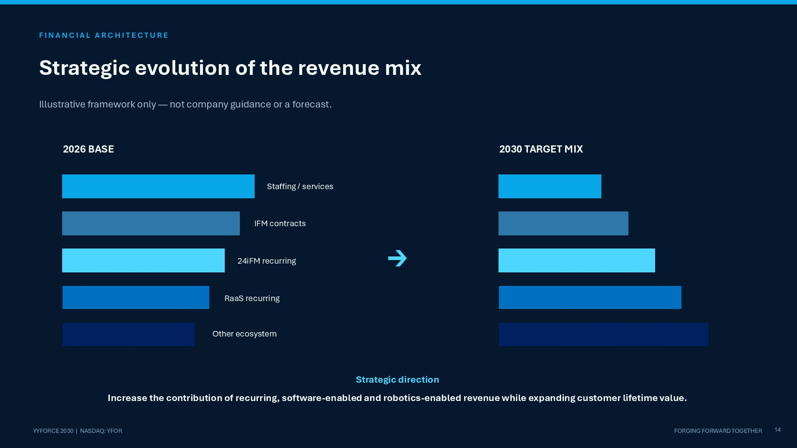
F I N A N C I A L A R C H I T E C T U R E Strategic evolution of the revenue mix Illustrative framework only — not company guidance or a forecast. 2026 BASE 2030 TARGET MIX Staffing / services IFM contracts 24iFM recurring RaaS recurring Other ecosystem → 14 YYFORCE 2030 | NASDAQ: YFOR FORGING FORWARD TOGETHER Strategic direction Increase the contribution of recurring, software - enabled and robotics - enabled revenue while expanding customer lifetime value.

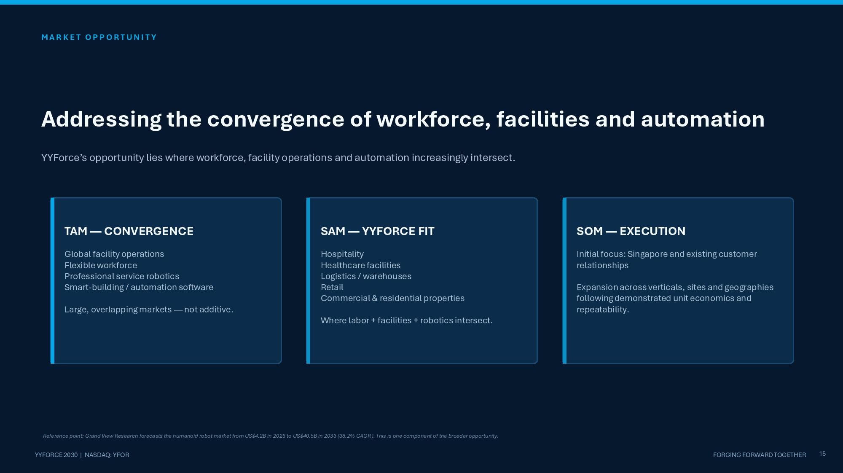
M A R K E T O P P O R T U N I T Y Addressing the convergence of workforce, facilities and automation YYForce’s opportunity lies where workforce, facility operations and automation increasingly intersect. TAM — CONVERGENCE Global facility operations Flexible workforce Professional service robotics Smart - building / automation software Large, overlapping markets — not additive. SAM — YYFORCE FIT Hospitality Healthcare facilities Logistics / warehouses Retail Commercial & residential properties Where labor + facilities + robotics intersect. SOM — EXECUTION Initial focus: Singapore and existing customer relationships Expansion across verticals, sites and geographies following demonstrated unit economics and repeatability. 15 YYFORCE 2030 | NASDAQ: YFOR FORGING FORWARD TOGETHER Reference point: Grand View Research forecasts the humanoid robot market from US$4.2B in 2026 to US$40.5B in 2033 (38.2% CAGR). This is one component of the broader opportunity.

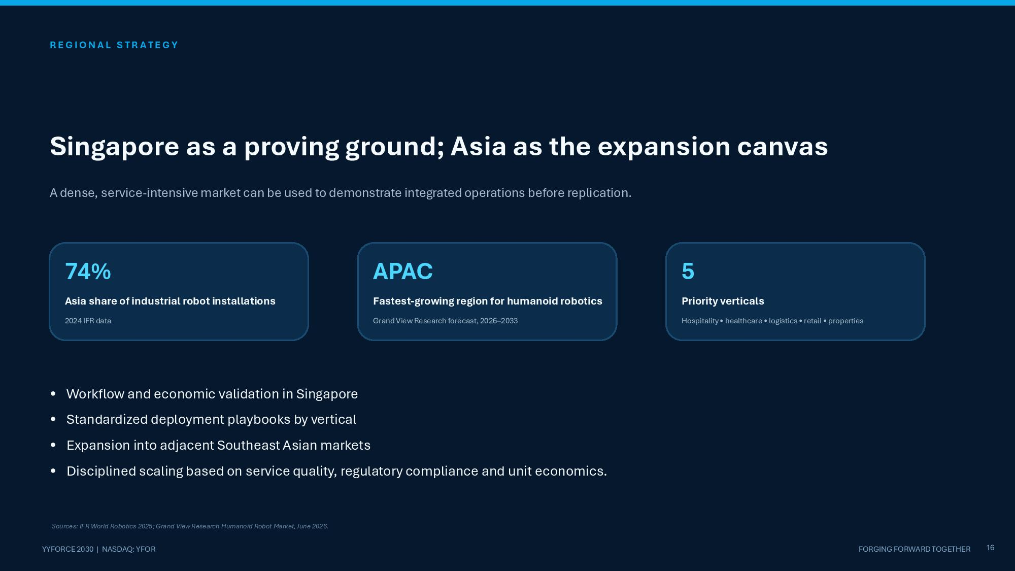
R E G I O N A L S T R A T E G Y Singapore as a proving ground; Asia as the expansion canvas A dense, service - intensive market can be used to demonstrate integrated operations before replication. 74% Asia share of industrial robot installations 2024 IFR data APAC Fastest - growing region for humanoid robotics Grand View Research forecast, 2026 – 2033 5 Priority verticals Hospitality • healthcare • logistics • retail • properties 16 YYFORCE 2030 | NASDAQ: YFOR FORGING FORWARD TOGETHER • Workflow and economic validation in Singapore • Standardized deployment playbooks by vertical • Expansion into adjacent Southeast Asian markets • Disciplined scaling based on service quality, regulatory compliance and unit economics. Sources: IFR World Robotics 2025; Grand View Research Humanoid Robot Market, June 2026.

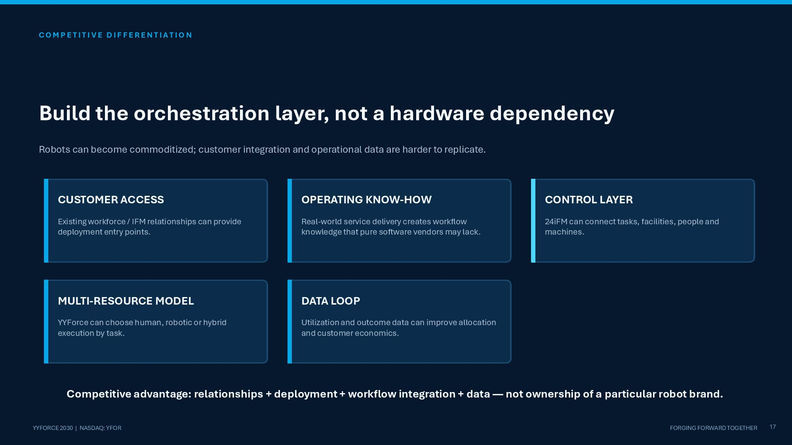
C O M P E T I T I V E D I F F E R E N T I A T I O N Build the orchestration layer, not a hardware dependency Robots can become commoditized; customer integration and operational data are harder to replicate. CUSTOMER ACCESS Existing workforce / IFM relationships can provide deployment entry points. OPERATING KNOW - HOW Real - world service delivery creates workflow knowledge that pure software vendors may lack. CONTROL LAYER 24iFM can connect tasks, facilities, people and machines. MULTI - RESOURCE MODEL YYForce can choose human, robotic or hybrid execution by task. DATA LOOP Utilization and outcome data can improve allocation and customer economics. 17 YYFORCE 2030 | NASDAQ: YFOR FORGING FORWARD TOGETHER Competitive advantage: relationships + deployment + workflow integration + data — not ownership of a particular robot brand.

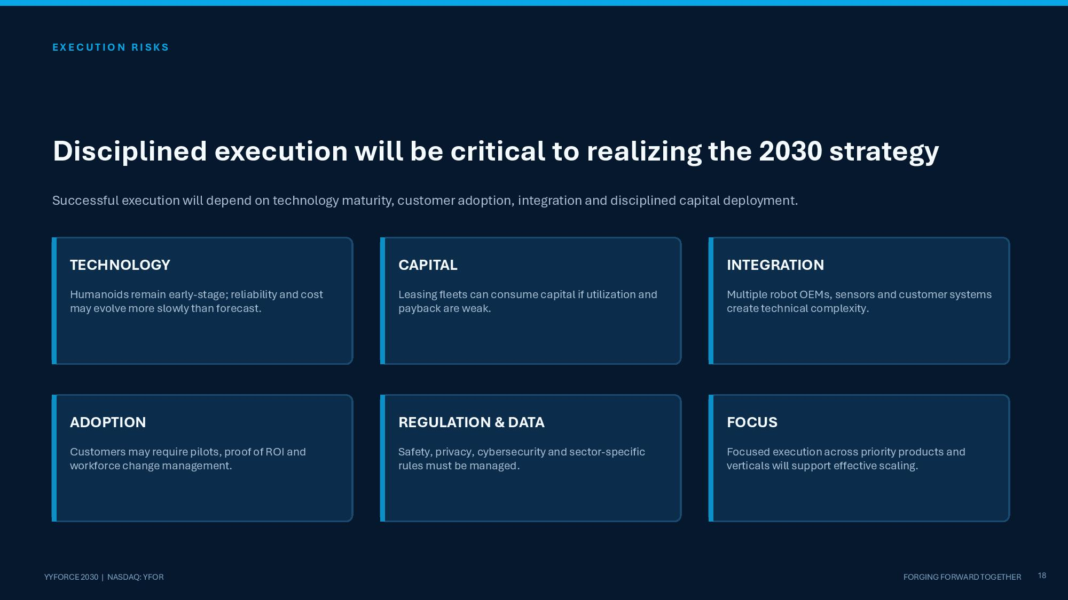
E X E C U T I O N R I S K S Disciplined execution will be critical to realizing the 2030 strategy Successful execution will depend on technology maturity, customer adoption, integration and disciplined capital deployment. TECHNOLOGY Humanoids remain early - stage; reliability and cost may evolve more slowly than forecast. CAPITAL Leasing fleets can consume capital if utilization and payback are weak. INTEGRATION Multiple robot OEMs, sensors and customer systems create technical complexity. ADOPTION Customers may require pilots, proof of ROI and workforce change management. REGULATION & DATA Safety, privacy, cybersecurity and sector - specific rules must be managed. FOCUS Focused execution across priority products and verticals will support effective scaling. 18 YYFORCE 2030 | NASDAQ: YFOR FORGING FORWARD TOGETHER

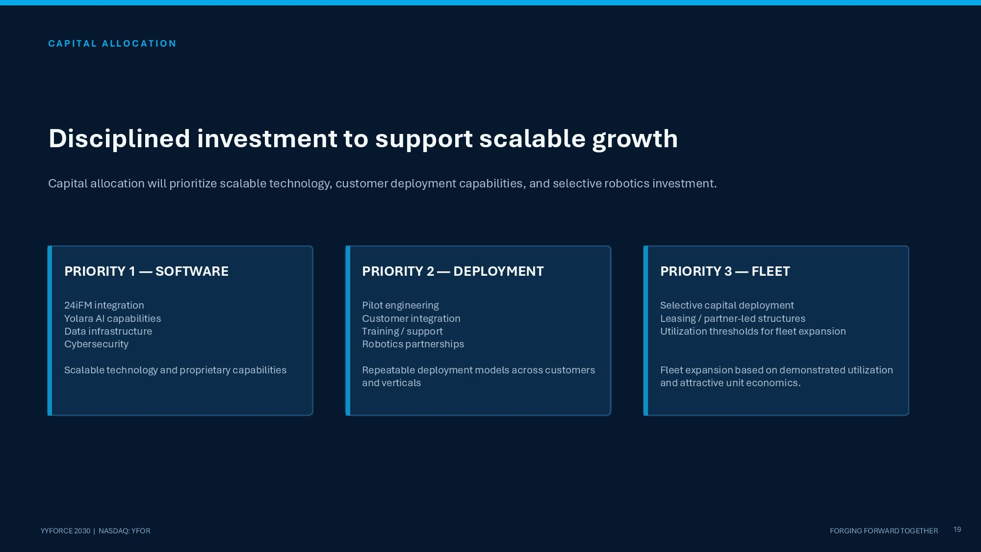
C A P I T A L A L L O C A T I O N Disciplined investment to support scalable growth Capital allocation will prioritize scalable technology, customer deployment capabilities, and selective robotics investment. PRIORITY 1 — SOFTWARE 24iFM integration Yolara AI capabilities Data infrastructure Cybersecurity Scalable technology and proprietary capabilities PRIORITY 2 — DEPLOYMENT Pilot engineering Customer integration Training / support Robotics partnerships Repeatable deployment models across customers and verticals PRIORITY 3 — FLEET Selective capital deployment Leasing / partner - led structures Utilization thresholds for fleet expansion Fleet expansion based on demonstrated utilization and attractive unit economics. 19 YYFORCE 2030 | NASDAQ: YFOR FORGING FORWARD TOGETHER

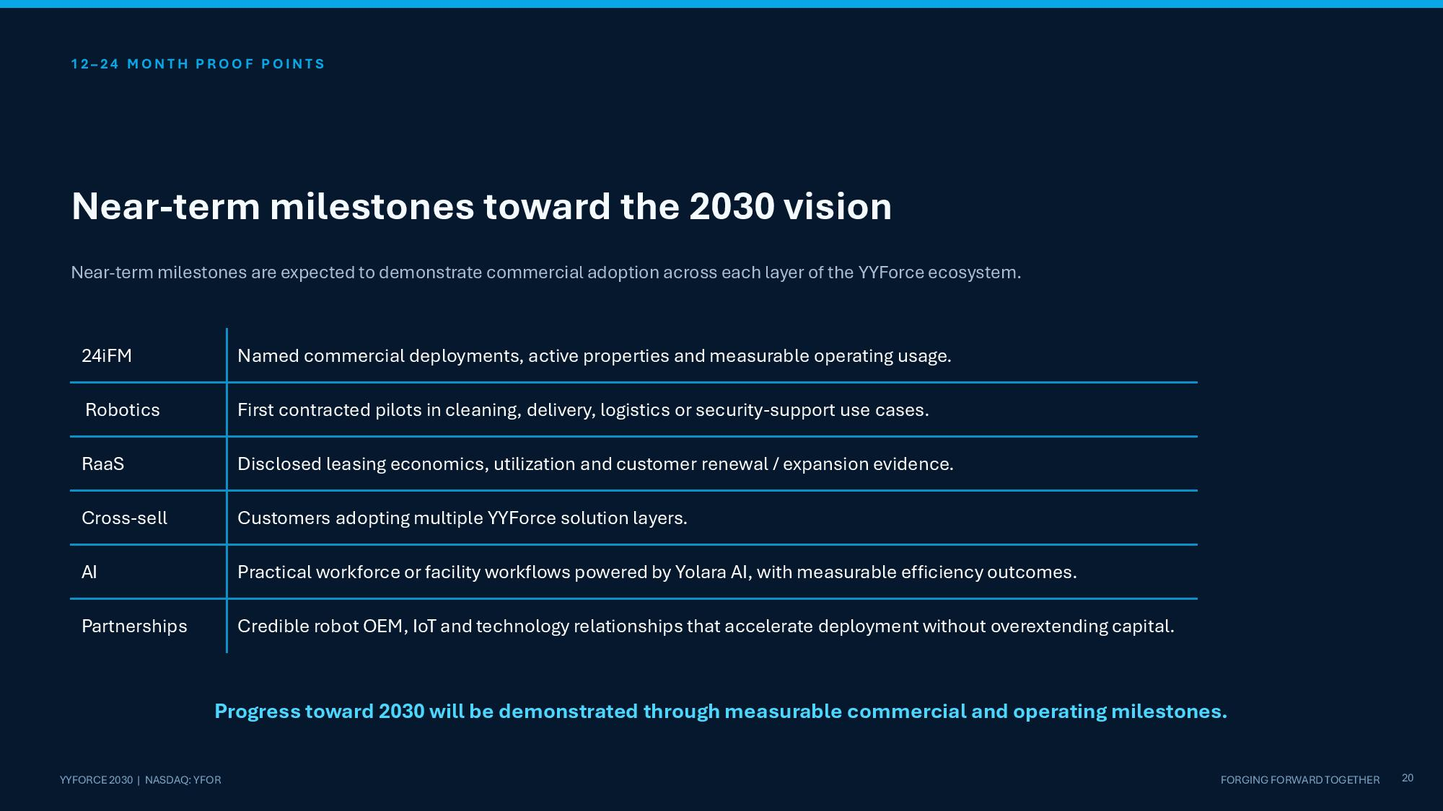
12 – 2 4 M O N T H P R O O F P O I N T S 20 YYFORCE 2030 | NASDAQ: YFOR FORGING FORWARD TOGETHER Near - term milestones toward the 2030 vision Near - term milestones are expected to demonstrate commercial adoption across each layer of the YYForce ecosystem. Progress toward 2030 will be demonstrated through measurable commercial and operating milestones. Named commercial deployments, active properties and measurable operating usage. 24iFM First contracted pilots in cleaning, delivery, logistics or security - support use cases. Robotics Disclosed leasing economics, utilization and customer renewal / expansion evidence. RaaS Customers adopting multiple YYForce solution layers. Cross - sell Practical workforce or facility workflows powered by Yolara AI, with measurable efficiency outcomes. AI Credible robot OEM, IoT and technology relationships that accelerate deployment without overextending capital. Partnerships

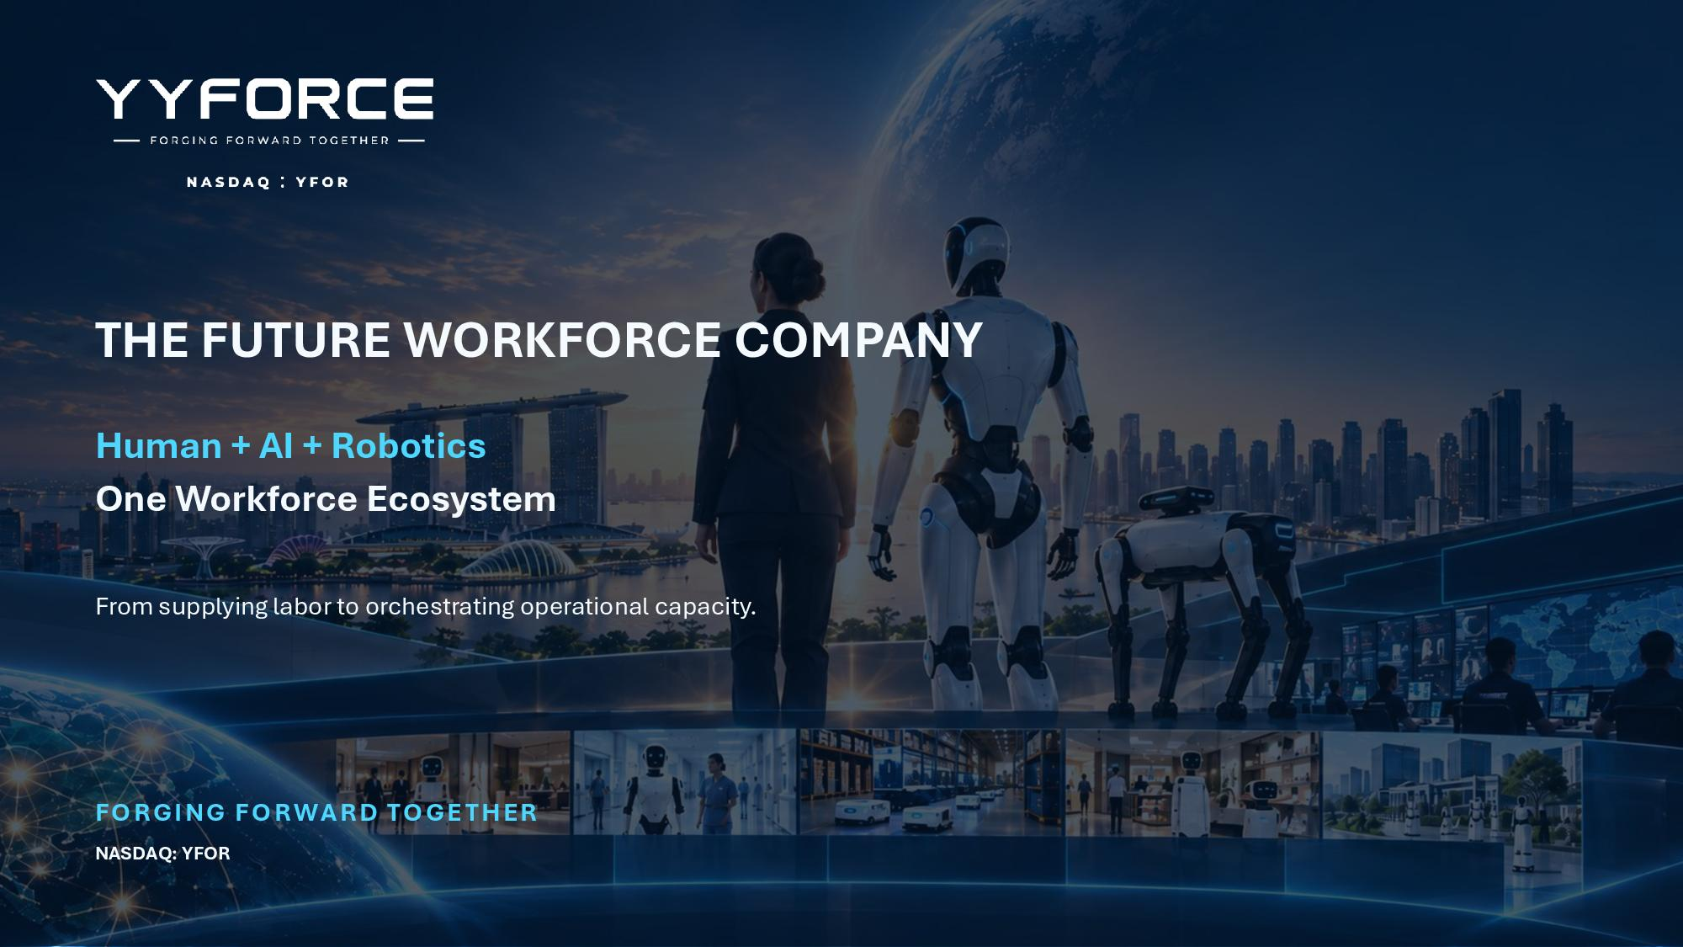
THE FUTURE WORKFORCE COMPANY Human + AI + Robotics One Workforce Ecosystem From supplying labor to orchestrating operational capacity. FORGING FORWARD TOGETHER NASDAQ: YFOR

